**LAB EXPERIMENT 12**

**Aim:** To design an ALU (Arithmetic Logic Unit) in XILINX using Verilog language of Coding.

**Theory:** An arithmetic-logic unit (ALU) is the part of a computer [processor](https://whatis.techtarget.com/definition/processor) ([CPU](https://whatis.techtarget.com/definition/processor)) that carries out arithmetic and logic operations on the operands in computer [instruction](https://whatis.techtarget.com/definition/instruction) [word](https://whatis.techtarget.com/definition/word)s. In some processors, the ALU is divided into two units, an arithmetic unit (AU) and a logic unit (LU). The ALU performs simple addition, subtraction, multiplication, division, and logic operations, such as OR and AND. The memory stores the program's instructions and data.

Circuit Diagram:

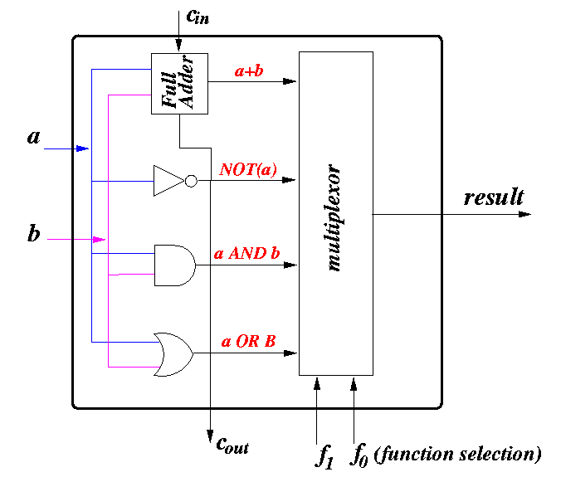

Truth Table:

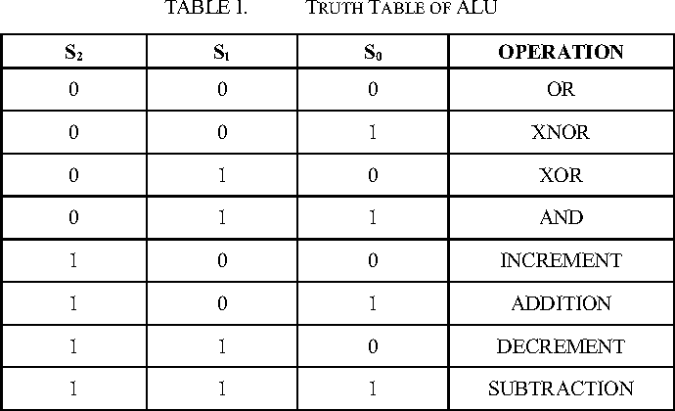

**Verilog Code of the Program and Outputs**

1. **Verilog Code of the Program:**

module ALU_Rahil_062(

input [7:0] a,

input [7:0] b,

input [7:0] c,

output reg [8:0] x,x1,x2,x3,x4,x5,x6,x7

);

always @(a or b)

begin

case(c)

3'd0: x=a+b;

3'd1: x1=a-b;

3'd2: x2=a*b;

3'd3: x3=a>>1; // logical right shifting

3'd4: x4=b<<1; // shifting left

3'd5: x5=a&b;

3'd6: x6=a|b;

3'd7: x7=a^b;

endcase

end

endmodule

1. **Verilog Code for testbench:**

module ALU_testbench_Rahil_062;

// Inputs

reg [7:0] a;

reg [7:0] b;

reg [7:0] c;

// Outputs

wire [8:0] x;

wire [8:0] x1;

wire [8:0] x2;

wire [8:0] x3;

wire [8:0] x4;

wire [8:0] x5;

wire [8:0] x6;

wire [8:0] x7;

// Instantiate the Unit Under Test (UUT)

ALU_Rahil_062 uut (

.a(a),

.b(b),

.c(c),

.x(x),

.x1(x1),

.x2(x2),

.x3(x3),

.x4(x4),

.x5(x5),

.x6(x6),

.x7(x7)

);

initial begin

a=1; b=4; c=0;

#20 c=1; a=12; b=5;

#20 c=2; a=10; b=24;

#20 c=3; a=15; b=36;

#20 c=4; a=20; b=48;

#20 c=5; a=25; b=60;

#20 c=6; a=30; b=72;

#20 c=7; a=35; b=84;

end

endmodule

1. **Screenshots of the Program and Outputs:**

1. **RTL Schematics:**

